ELEG 309 - Example Problems Chapter 2-1

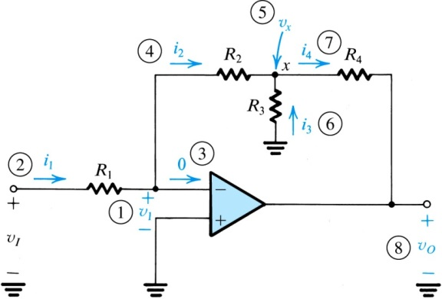**Example 2.2**

Assuming the op amp to be ideal, derive an expression for the closed-loop gain of the circuit shown in Fig. 2.8.

**Figure 2.8:** Circuit for Example 2.2. The circled numbers indicate the sequence of the steps in the analysis.

Use this circuit to design an inverting amplifier with a gain of 100 and an input resistance of 1 MΩ. Assume that for practical reasons it is required not to use resistors greater than 1 MΩ.

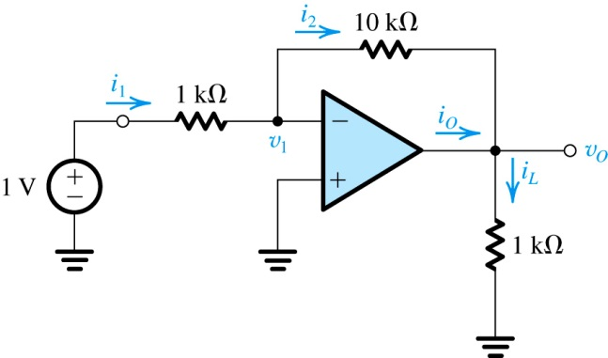

**Practice Exercise 2.6**

Determine the values of *v*1*,i*1*,i*2*,vO,iL*, and *iO*. Also determine the voltage gain, current gain, and power gain.

**Figure E2.6**

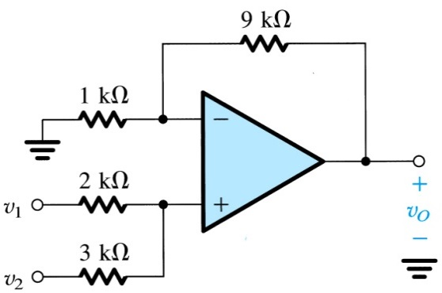**Exercise 2.9**

Use the superposition principle to find the output voltage of the circuit shown in Fig. E2.9.

**Figure E2.9**

**Exercise 2.13**

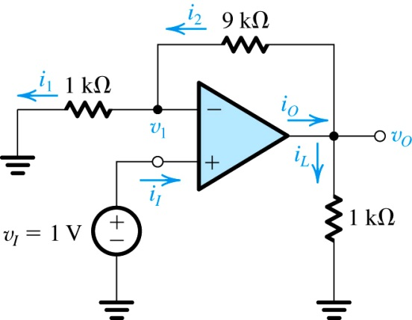For the circuit in Fig. E2.13 find the values of *iI, v*1*, i*1*, i*2*, vO, iL,* and *iO*, Also find the voltage gain *vO/vI*, the current gain *iL/iI,* and the power gain *PL/PI.*

**Figure E2.13**